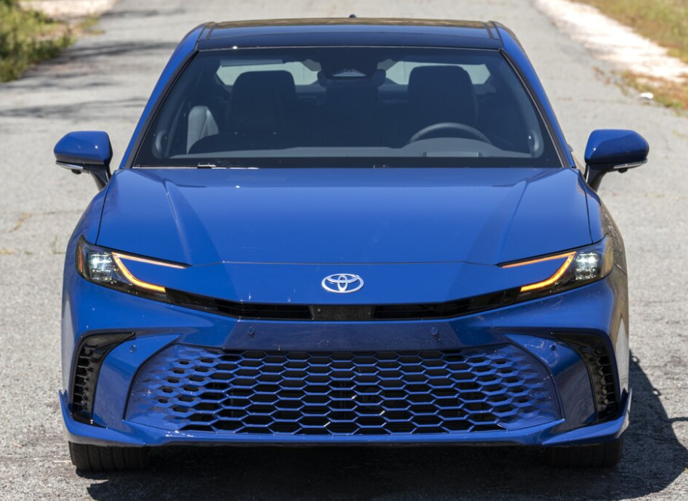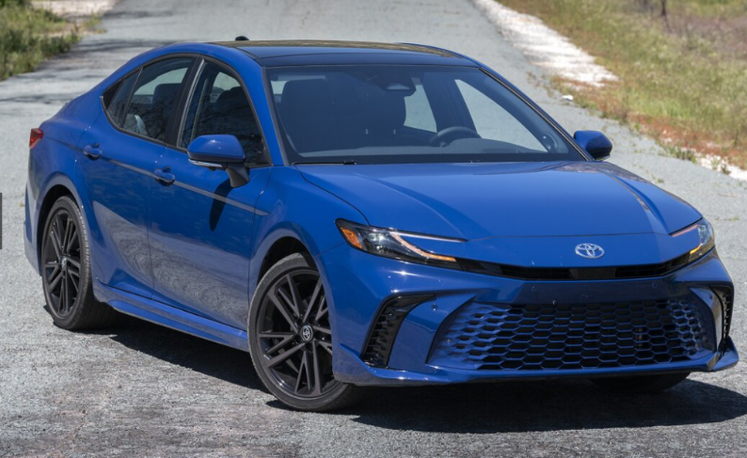

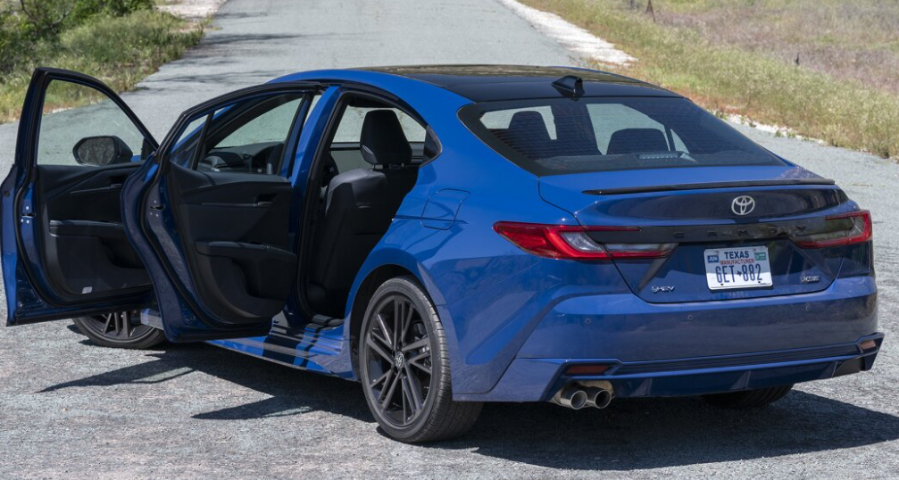

**Main specifications** for the **2025 Toyota Camry**:

**🔋 Powertrain & Performance**

* **Hybrid-only drivetrain** (no gas-only or V6 options)
* **FWD**: 2.5 L inline-4 + electric motor → 225 hp total
* **AWD**: adds rear electric motor → 232 hp total
* **Transmission**: Continuously Variable Transmission (CVT)/e-CVT
* **Fuel economy (EPA)**: FWD LE – 53 mpg city / 50 mpg highway (~51 mpg combined); AWD – ~51/49 mpg; sportier XSE AWD – ~44/43 mpg
* **0–60 mph**: ~6.8 seconds for XSE AWD

**📏 Dimensions**

* **Length**: ~193.5 in (~4 915 mm)
* **Width**: ~72.4 in (1 839 mm)
* **Height**: ~56.9 in (1 445 mm)
* **Wheelbase**: ~111.2 in (2 824 mm
* **Curb weight**: ~3 538 lb (FWD) to ~3 774 lb (AWD XSE)
* **Trunk space**: ~15.1 cu ft

**🛋 Interior & Features**

* **Cockpit displays**: Standard 7–8″ touchscreen + 7″ digital cluster; available 12.3″ infotainment + 12.3″ digital cluster on XLE/XSE **Connectivity**: Wireless Apple CarPlay & Android Auto, wireless charging across trims
* **Comfort**: Dual-zone climate control, heated seats/steering wheel (upper trims), ambient lighting, acoustic laminated glass
* **Optional extras**: Panoramic sunroof, JBL premium audio, head-up display, Digital Key

**🛡 Safety & Driver-Assistance**

* **Toyota Safety Sense 3.0** standard (all trims):  
  Adaptive Cruise Control, Pre-Collision with pedestrian/cyclist detection, Lane Keep Assist, Automatic High Beams, Blind-Spot Monitor & Rear Cross-Traffic Alert (higher trims), Curve Speed Assist

**💵 Pricing & Warranty**

* **Starting MSRP**: from ~$28,700 (FWD LE) to ~$37,220 (AWD XSE)
* **Warranty**:  
  – Basic: 3 yr/36,000 mi  
  – Powertrain: 5 yr/60,000 mi  
  – Hybrid components: 8 yr/100,000 mi; battery: 10 yr/150,000 mi  
  – Includes 2 yr/25,000 mi scheduled maintenance

**🚗 Chassis & Handling**

* **Suspension**: Front MacPherson strut; rear multi-link
* **Performance-tuned setup** on SE/XSE trims
* **Wheels**: Standard 17″; up to 19″ alloys on sport trims

**Summary**: The 2025 Camry is now fully hybrid—FWD or AWD—with up to 232 hp and impressive fuel economy (~51 mpg FWD). It features modernized tech, robust safety, and retains its spacious, comfortable midsize sedan appeal.